Activity Title | Date | Description (1-2 Sentences)
Litter Clean ups  at THS | 2021-2022 | Student leaders led weekly clean ups around Towson High School and the community around Towson High to pick up trash. Excel document attached of clean up attendance. | 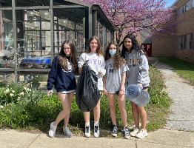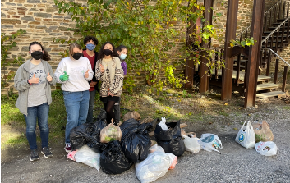  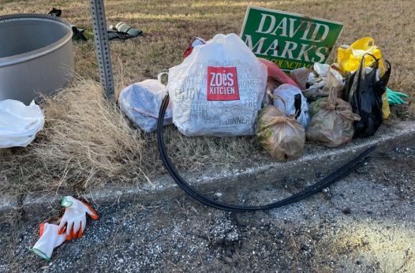
Rain Barrel installation | Spring 2019 | A 55-gallon rain barrel was installed by the THS Environmental Club. Water collected in the rain barrel will be used to water the native garden around the greenhouse, plants inside the greenhouse, and the memorial native garden. | 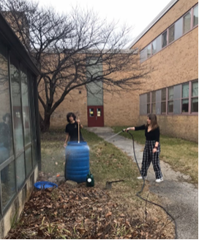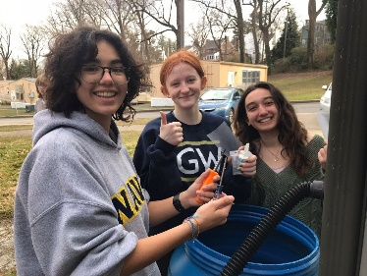  Students in environmental club install and use the rain barrel for the first time.
Stream Cleaning | Every Spring | During club-lead campus cleanups and through Earth System student advocacy, the 1,273 ft of stream was cleaned, and waste was removed.  Towson Run Stream runs through the Towson High Campus, and this eliminates trash from getting to the stream. | 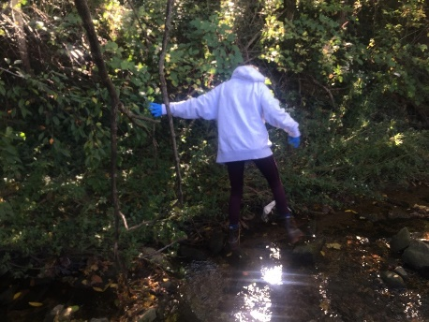  G. Kral cleans the stream during a stream clean up
Earth Day Litter Clean Competition | Every April 22, pictures from 2022 | Clubs from Towson High had a competition for the most litter cleaned up on Earth Day. | 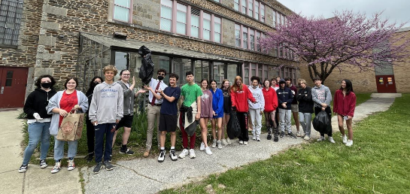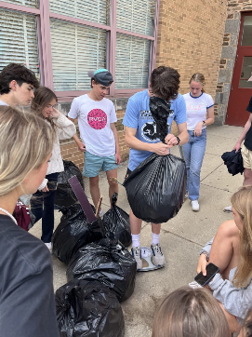
Students create hydroponic or aquaponic gardening systems | Spring of 2023 | Mr. Schenning (aquatics teacher, environmental club advisory) and aquatics students have been working hard to set up an aquaponics system, which should be up and running soon. | 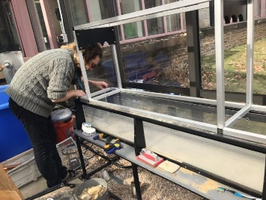 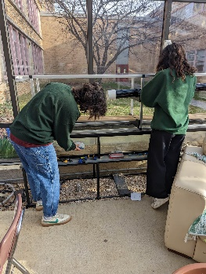 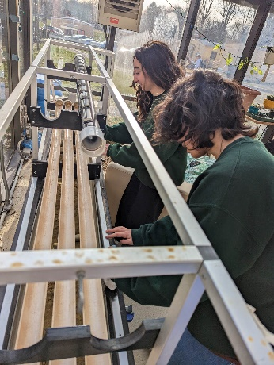Mr. Schenning and students Beliz and Sonya work to build the aquaponic system in the greenhouse.
The THS Tributary Club hosted the Tributary Festival | Fall of 2021-Present | The THS Tributary Club hosted numerous Tributary Festivals, a student-led benefit music festival to support the Chesapeake Bay, raising over $19,000 to support the CBF over 2 large-scale events. | 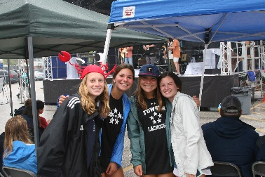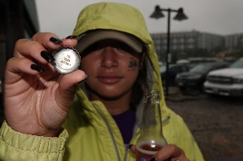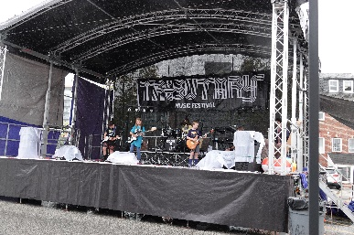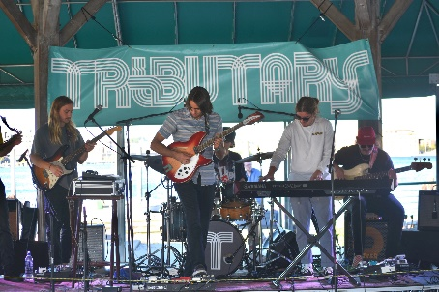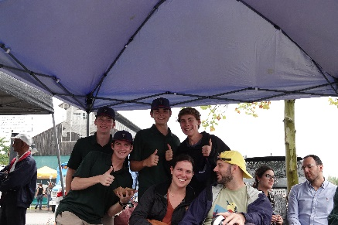  Pictures of THS students at the Tributary Festival in 2022.

